Appendix A

UECS1104/1144 Object-Oriented Application Development Group Assignment

Name : <Chew Wen Han, Kamarul Zuhayr Bin Kamarul Zaman, Wong Ke Xin–Chin Rou Xing>

Course: < SE >

|  |  |  |  |  |  |  |  |  |
| --- | --- | --- | --- | --- | --- | --- | --- | --- |
|  | **Component** | **Missing** | **Poor** | **Average** | **Good** | **Excellent** | **Max Marks** | **Marks Obtained** |
| **Part 2** | System  Requirements  Specification |  |  |  |  |  | **10** |  |
| **Part 3** | Class Diagram (Notation used, relationship, multiplicities) |  |  |  |  |  | **20** |  |
| **Part 4** | Implementation/  Functionalities |  |  |  |  |  | **40** |  |
| File Handling |  |  |  |  |  | **5** |  |
| Exception  Handling |  |  |  |  |  | **5** |  |
| Sample of Input  data |  |  |  |  |  | **5** |  |
| Sample Output  (Screenshot) |  |  |  |  |  | **5** |  |
| Presentation /  General Effort |  |  |  |  |  | **10** |  |
| **Total** | | | |  |  |  | **100** |  |
| Remarks (for Examiner only): | | | |  |  |  |  |  |

**Table of Contents**

**Part 2 System Requirements Specification 3 - 29**

Use requirements 3

Use case 5

**Use case description 6 - 29**

Login account 6

View bicycle list 8

Add bicycle 10

Delete bicycle 12

Update bicycle details 13

View staff list 15

View customer list 16

Delete customer 18

View rental order list 20

Update rental order details 22

View personal details 24

Update personal details 25

Place rental order 26

Check rental history 28

**Part 4 Sample of Input data Sample Output (Screenshot) 30 - 67**

Text file before the program 30

**Login account** **31 - 65**

Login staff account 32

Login customer account 54

Exit system 65

Text file after the program66

**Part 2: System Requirements Specification**

**User Requirements**

|  |  |
| --- | --- |
| ID | Requirement |
| FR01 | The system shall allow user to login the system with his username and password. |
| FR02 | The system shall allow customer to register customer account by providing customer’s personal information. |
| FR03 | The system shall allow the user to view bicycle list. |
| FR04 | The system shall allow the staff to add bicycle data. |
| FR05 | The system shall allow the staff to delete bicycle data. |
| FR06 | The system shall allow the staff to update the bicycle data. |
| FR07 | The system shall allow the user to view bicycle details according to the bicycle ID. |
| FR08 | The system shall allow the staff to view staff list. |
| FR09 | The system shall allow the staff to view customer list. |
| FR10 | The system shall allow the staff to view customer details according to the customer ID. |
| FR11 | The system shall allow the staff to delete customer. |
| FR12 | The system shall allow the staff to view rental order list. |
| FR13 | The system shall allow the staff to view rental order details according to the rental order ID. |
| FR14 | The system shall allow the staff to update rental order details. |
| FR15 | The system shall allow customer to view his own personal details. |
| FR16 | The system shall allow customer to update his own personal details. |
| FR17 | The system shall allow the customer to place rental order to rent bicycle. |
| FR18 | The system shall generate rental order receipt. |
| FR19 | The system shall allow customer to check his own rental history. |
| FR20 | The system shall allow customer to search his own rental order record according to the rental order ID. |

**Use Case**

**Use Case Description [Hourly Bicycle Rental system]**

|  |  |  |
| --- | --- | --- |
| Use Case Name**: Login account** | ID**: UC01** | Importance Level**: High** |
| Primary Actor**: User**  **(Customer, Staff)** | Use Case Type**: Detail, Essential** | |
| Stakeholders and Interests**:**  **Customer - wants to login Hourly Bicycle Rental system for further action.**  **Staff - wants to login the Hourly Bicycle Rental system to manage content of the system.** | | |
| Brief Description**: This use case describes how the user login Hourly Bicycle Rental system and accessing personal accounts.** | | |
| Trigger**:** **User wants to login into their account to use the function of the Hourly Bicycle Rental system.** | | |
| Relationships:  Association **: User**  Include **: N/A**  Extend **: Register customer**  Generalization**: Staff, Customer** | | |
| Normal Flow of Events**:**   1. **The user accesses the Hourly Bicycle Rental system.** 2. **The user is allowed to choose their role either Staff or Customer.** 3. **The user provides the correct username and password to sign in their account.** 4. **The system validates whether the user exists in the database.** 5. **If the customer is not in the database, perform Sub-flow 5.1 and Sub-flow 5.2.** 6. **The staff is not allowed to create a new account if he/she is not in the database.** 7. **If the user fails to login, perform Sub-flow 7.1.** 8. **Customer will login to the customer interface while Staff will login to the Staff interface.** | | |
| Sub-flows**:**  **5.1 The system will perform use case Register customer.**  **5.2 The system will require the user to provide his personal details such as customer ID, name, password, gender, telephone number, email, and address.**  **7.1 The user repeats Step 1 to 3 to sign in the Hourly Bicycle Rental system.** | | |
| Alternate/Exceptional Flows:  1a. The user must successfully log into the Hourly Bicycle Rental system using the correct username and password. | | |

**Use Case Description [Hourly Bicycle Rental system]**

|  |  |  |
| --- | --- | --- |
| Use Case Name**: View bicycle list** | ID**: UC03** | Importance Level**: High** |
| Primary Actor**: User (Customer, Staff)** | Use Case Type**: Detail, Essential** | |
| Stakeholders and Interests**:**  **Customer - wants to view bicycle list and search bicycle details before place rental order.**  **Staff – wants to view bicycle list to manage the details of bicycle.** | | |
| Brief Description**: This use case describes how the user view bicycle list and look into details of the bicycle.** | | |
| Trigger**:** **The user wants to view the list and the details of the bicycle.** | | |
| Relationships:  Association **: User**  Include **: N/A**  Extend **: View bicycle details**  Generalization**: Staff, Customer** | | |
| Normal Flow of Events**:**   1. **The user wants to view the bicycle list in the system.** 2. **The system displays the overall bicycle list that record in database.** 3. **The user provides correct bicycle ID to look into bicycle details.** 4. **If the user provides the correct bicycle ID, perform Sub-flow 4.1 and Sub-flow 4.2.** 5. **If the user provides the incorrect bicycle ID, perform Sub-flow 5.3 and Sub-flow 5.4.** 6. **The user can keep searching by providing the bicycle ID or exit the function.** | | |
| Sub-flows**:**  **4.1 The system will perform use case View bicycle details.**  **4.2 The system will display all the bicycle details such as bicycle ID, name, type, size, rental price per hour and description.**  **5.3 The system will allow user to either keep searching the bicycle or exit the function.**  **5.4 The user will repeat Step 3 if the user wants to keep searching the bicycle.** | | |
| Alternate/Exceptional Flows:  1a. The user must successfully log into the Hourly Bicycle Rental system using the correct username and password. | | |

**Use Case Description [Hourly Bicycle Rental system]**

|  |  |  |
| --- | --- | --- |
| Use Case Name**: Add bicycle** | ID**: UC04** | Importance Level**: High** |
| Primary Actor**: User (Staff)** | Use Case Type**: Detail, Essential** | |
| Stakeholders and Interests**:**  **Staff - wants to add a new bicycle data into the Hourly Bicycle Rental System.** | | |
| Brief Description**: This use case describes how the user (staff) add a new bicycle data into Hourly Bicycle Rental system.** | | |
| Trigger**:** **The user wants to add a new bicycle data into Hourly Bicycle Rental System.** | | |
| Relationships:  Association **: User**  Include **: N/A**  Extend **: N/A**  Generalization**: Staff** | | |
| Normal Flow of Events**:**   1. **The system will ask user to provide the bicycle ID to add in bicycle data.** 2. **If the bicycle ID provides in wrong format , perform Sub-flow 2.1.** 3. **The system will ask user to provide the bicycle name to add in bicycle data.** 4. **If the bicycle name provides in wrong format , perform Sub-flow 3.1.** 5. **The system will ask user to provide the bicycle size to add in bicycle data.** 6. **If the bicycle size provides in wrong format , perform Sub-flow 4.1.** 7. **The system will ask user to provide the bicycle type to add in bicycle data.** 8. **If the bicycle type provides in wrong format , perform Sub-flow 5.1.** 9. **The system will ask user to provide the bicycle price to add in bicycle data.** 10. **If the bicycle price provides in wrong format , perform Sub-flow 6.1.** 11. **The system will ask user to provide the bicycle description to add in bicycle data.** 12. **The system will add the bicycle and exit to staff menu.** | | |
| Sub-flows**:**  **2.1. The user will repeat Step 1.**  **3.1. The user will repeat Step 3.**  **4.1. The user will repeat Step 5.**  **5.1. The user will repeat Step 7.**  **6.1. The user will repeat Step 9.** | | |
| Alternate/Exceptional Flows:  1a. The Staff must successfully log into the Hourly Bicycle Rental system using the correct username and password. | | |

**Use Case Description [Hourly Bicycle Rental system]**

|  |  |  |
| --- | --- | --- |
| Use Case Name**: Delete bicycle** | ID**: UC05** | Importance Level**: High** |
| Primary Actor**: User (Staff)** | Use Case Type**: Detail, Essential** | |
| Stakeholders and Interests**:**  **Staff - wants to delete the whole specific bicycle data in the Hourly Bicycle Rental System.** | | |
| Brief Description**: This use case describes how the user (staff) delete specific bicycle data in Hourly Bicycle Rental system.** | | |
| Trigger**:** **The user wants to delete specific bicycle data in Hourly Bicycle Rental System.** | | |
| Relationships:  Association **: User**  Include **: N/A**  Extend **: N/A**  Generalization**: Staff** | | |
| Normal Flow of Events**:**   1. **The system will ask user to provide the bicycle ID that want to be deleted.** 2. **If the bicycle ID provides not match with database , perform Sub-flow 2.1.** 3. **The system will ask confirmation with user whether want to delete the bicycle data.** 4. **If the bicycle ID is in any rental order data in the system, the system will reject the delete request.** 5. **If the confirmation provided is incorrect, perform Sub-flow 4.1.** 6. **The specific bicycle data will be deleted.** 7. **The user will exit to the staff menu.** | | |
| Sub-flows**:**  **2.1. The user will repeat Step 1.**  **4.1. The user will repeat Step 3.** | | |
| Alternate/Exceptional Flows:  1a. The Staff must successfully log into the Hourly Bicycle Rental system using the correct username and password. | | |

**Use Case Description [Hourly Bicycle Rental system]**

|  |  |  |
| --- | --- | --- |
| Use Case Name**: Update bicycle details** | ID**: UC06** | Importance Level**: High** |
| Primary Actor**: User (Staff)** | Use Case Type**: Detail, Essential** | |
| Stakeholders and Interests**:**  **Staff - wants to update the specific bicycle data in the Hourly Bicycle Rental System.** | | |
| Brief Description**: This use case describes how the user (staff) update specific bicycle data in Hourly Bicycle Rental system.** | | |
| Trigger**:** **The user wants to update specific bicycle data in Hourly Bicycle Rental System.** | | |
| Relationships:  Association **: User**  Include **: View bicycle details**  Extend **: N/A**  Generalization**: Staff** | | |
| Normal Flow of Events**:**   1. **The system will ask user to provide the bicycle ID that want to be update.** 2. **If the bicycle ID provides not match with database, perform Sub-flow 2.1.** 3. **The system will perform use case** **View bicycle details to display the details of the bicycle.** 4. **The system will allow user to update in specific bicycle data which is bicycle name, type, description, size, and price per hour.** 5. **The system displays the original data for the specific bicycle details.** 6. **The system will allow the user to provide a new data to update the specific bicycle details.** 7. **The system will update the specific bicycle details in the bicycle rental system.** 8. **The user can keep updating by update the specific bicycle data or exit the function.** | | |
| Sub-flows**:**  **2.1. The user will repeat Step 1.** | | |
| Alternate/Exceptional Flows:  1a. The Staff must successfully log into the Hourly Bicycle Rental system using the correct username and password. | | |

**Use Case Description [Hourly Bicycle Rental system]**

|  |  |  |
| --- | --- | --- |
| Use Case Name**: View staff list** | ID**: UC08** | Importance Level**: High** |
| Primary Actor**: User (Staff)** | Use Case Type**: Detail, Essential** | |
| Stakeholders and Interests**:**  **Staff – wants to view staff who will be able to manage the bicycle rental system.** | | |
| Brief Description**: This use case describes how the user (staff) view the staff list that manage the system.** | | |
| Trigger**:** **The user which is staff wants to view the list of staff able to access and manage the system.** | | |
| Relationships:  Association **: User**  Include **: N/A**  Extend **: N/A**  Generalization**: Staff** | | |
| Normal Flow of Events**:**   1. **The user wants to view the staff that is record and able to manage the rental system.** 2. **The system displays the overall staff list that record in database.** 3. **The user will automatically exit back to staff menu after the staff list display.** | | |
| Sub-flows**:** | | |
| Alternate/Exceptional Flows:  1a. The Staff must successfully log into the Hourly Bicycle Rental system using the correct username and password. | | |

**Use Case Description [Hourly Bicycle Rental system]**

|  |  |  |
| --- | --- | --- |
| Use Case Name**: View customer list** | ID**: UC09** | Importance Level**: High** |
| Primary Actor**: User (Staff)** | Use Case Type**: Detail, Essential** | |
| Stakeholders and Interests**:**  **Staff – wants to view customer that use the bicycle rental system.** | | |
| Brief Description**: This use case describes how the user (staff) view the customer list that using the bicycle rental system.** | | |
| Trigger**:** **The user which is staff wants to view the list of customers that using the bicycle rental system.** | | |
| Relationships:  Association **: User**  Include **: View customer details**  Extend **: N/A**  Generalization**: Staff** | | |
| Normal Flow of Events**:**   1. **The user wants to view the customer that is record and current using the bicycle rental system.** 2. **The system displays the overall customer list that record in database.** 3. **The system will ask user to provide the customer ID for searching.** 4. **If the customer ID provided match with the database, perform Sub-flow 4.1 and Sub-flow 4.2.** 5. **If the customer ID provided not match with database, perform Sub-flow 5.1 and Sub-flow 5.2.** 6. **The user can keep searching by providing the customer ID or exit the function.** | | |
| Sub-flows**:**  **4.1 The system will perform use case View customer details.**  **4.2 The system will display the customer details such as customer ID, name, password, gender, telephone number, email, and address with the customer ID provided.**  **5.1 The system will allow user to either keep searching the customer or exit the function.**  **5.2 The user will repeat Step 3 if the user wants to keep searching the customer.** | | |
| Alternate/Exceptional Flows:  1a. The Staff must successfully log into the Hourly Bicycle Rental system using the correct username and password. | | |

**Use Case Description [Hourly Bicycle Rental system]**

|  |  |  |
| --- | --- | --- |
| Use Case Name**: Delete customer** | ID**: UC11** | Importance Level**: High** |
| Primary Actor**: User (Staff)** | Use Case Type**: Detail, Essential** | |
| Stakeholders and Interests**:**  **Staff – wants to delete the whole customer data from Hourly Bicycle Rental system.** | | |
| Brief Description**: This use case describes how the user (staff) search the customer and delete the customer data.** | | |
| Trigger**:** **User (staff) want to delete the customer data from the Hourly Bicycle Rental system.** | | |
| Relationships:  Association **: User**  Include **: View customer details**  Extend **: N/A**  Generalization**: Staff** | | |
| Normal Flow of Events**:**   1. **The user allows to provide a customer ID that need to delete.** 2. **If the customer is available, perform Sub-flow 2.1.** 3. **If the customer is not available, perform Sub-flow 3.1 and Sub-flow 3.2.** 4. **The system will ask confirmation from user to delete the customer.** 5. **If the user confirms to delete the customer, perform Sub-flow 5.1.** 6. **If the customer ID is linked to any rental order in the system, the system will reject the delete request.** 7. **The system will exit the function.** | | |
| Sub-flows**:**  **2.1 The system will perform use case** **View customer details to display the customer details that match with the customer ID provided.**  **3.1 The system will allow user to either keep searching the customer or exit the function.**  **3.2 The user will repeat Step 1 if the user wants to keep searching and delete the customer.**  **5.1 The system will delete all the customer data match with customer ID provided.** | | |
| Alternate/Exceptional Flows:  1a. The Staff must successfully log into the Hourly Bicycle Rental system using the correct username and password. | | |

**Use Case Description [Hourly Bicycle Rental system]**

|  |  |  |
| --- | --- | --- |
| Use Case Name**: View rental order list** | ID**: UC12** | Importance Level**: High** |
| Primary Actor**: User (Staff)** | Use Case Type**: Detail, Essential** | |
| Stakeholders and Interests**:**  **Staff – wants to view the rental order list of customers via Hourly Bicycle Rental system.** | | |
| Brief Description**: This use case describes how the user (staff) view rental list of customers.** | | |
| Trigger**:** **User (staff) want to view rental order list of customers via Hourly Bicycle Rental system.** | | |
| Relationships:  Association **: User**  Include **: View rental order details**  Extend **: N/A**  Generalization**: Staff** | | |
| Normal Flow of Events**:**   1. **The user wants to view the rental order list of the customer via bicycle rental system.** 2. **The system displays all the rental order list that recorded in the database.** 3. **The system will allow user to provide rental ID to view rental order details.** 4. **If the rental ID provided match with database, perform Sub-flow 4.1 and Sub-flow 4.2.** 5. **If the rental ID provided does not match with database, perform Sub-flow 5.1** 6. **The user can keep searching by providing the rental ID or exit the function.** | | |
| Sub-flows**:**  **4.1 The system will perform use case View rental order details.**  **4.2 The system will display staff ID, rental ID, customer ID, order date, date of rental, total rental period, total price, and the bicycle the customer ordered.**  **5.1 The system requires user to repeat Step 3.** | | |
| Alternate/Exceptional Flows:  1a. The Staff must successfully log into the Hourly Bicycle Rental system using the correct username and password. | | |

**Use Case Description [Hourly Bicycle Rental system]**

|  |  |  |
| --- | --- | --- |
| Use Case Name**: Update rental order details** | ID**: UC14** | Importance Level**: High** |
| Primary Actor**: User (Staff)** | Use Case Type**: Detail, Essential** | |
| Stakeholders and Interests**:**  **Staff – wants to update the rental order details of customer via Hourly Bicycle Rental system.** | | |
| Brief Description**: This use case describes how the user (staff) update the rental details of the customer** | | |
| Trigger**:** **User (staff) want to update rental order details of customers via Hourly Bicycle Rental system.** | | |
| Relationships:  Association **: User**  Include **: View rental order details**  Extend **: N/A**  Generalization**: Staff** | | |
| Normal Flow of Events**:**   1. **The system performs the use case View rental list.** 2. **The system displays all the rental order that recorded in the database.** 3. **The system will allow user to provide rental ID to view rental order details.** 4. **If the rental ID provided match with database, perform Sub-flow 4.1 and Sub-flow 4.2.** 5. **If the rental ID provided does not match with database, perform Sub-flow 5.1.** 6. **The user can keep searching by providing the rental ID or exit the search rental ID function.** 7. **The system will allow user to provide a rental ID for update rental details.** 8. **If rental ID match with database, perform Sub-flow 9.1.** 9. **If the rental ID does not match with database, perform Sub-flow 5.1.** 10. **The system will update the details of the rental order.** 11. **The system will then exit to staff menu.** | | |
| Sub-flows**:**  **4.1 The system will perform use case View rental order details.**  **4.2 The system will display staff ID, rental ID, customer ID, order date, date of rental, total rental period, total price, and the bicycle the customer ordered.**  **5.1 The system requires user to repeat Step 3.**  **9.1 The system will allow user to either update the rental status or staff ID.** | | |
| Alternate/Exceptional Flows:  1a. The user must successfully log into the Hourly Bicycle Rental system using the correct username and password. | | |

**Use Case Description [Hourly Bicycle Rental system]**

|  |  |  |
| --- | --- | --- |
| Use Case Name**: View personal details** | ID**: UC15** | Importance Level**: High** |
| Primary Actor**: User (Customer)** | Use Case Type**: Detail, Essential** | |
| Stakeholders and Interests**:**  **Customer - wants to view his personal details.** | | |
| Brief Description**: This use case describes how the user(customer) view personal details via Hourly Bicycle Rental system.** | | |
| Trigger**:** **The user wants to view the personal details that registered in Hourly Bicycle Rental System.** | | |
| Relationships:  Association **: User**  Include **: N/A**  Extend **: N/A**  Generalization**: Customer** | | |
| Normal Flow of Events**:**   1. **The system will display the details of customer such as customer ID, name, password, gender, telephone number, email, and address.** 2. **The user will automatically exit the function and back to customer menu after display.** | | |
| Sub-flows**:** | | |
| Alternate/Exceptional Flows:  1a. The Customer must successfully log into the Hourly Bicycle Rental system using the correct username and password. | | |

**Use Case Description [Hourly Bicycle Rental system]**

|  |  |  |
| --- | --- | --- |
| Use Case Name**: Update personal details** | ID**: UC16** | Importance Level**: High** |
| Primary Actor**: User (Customer)** | Use Case Type**: Detail, Essential** | |
| Stakeholders and Interests**:**  **Customer – wants to update the personal details of via Hourly Bicycle Rental system.** | | |
| Brief Description**: This use case describes how the user (customer) update their personal details in Hourly Bicycle Rental System.** | | |
| Trigger**:** **User (customer) want to update personal details of customers via Hourly Bicycle Rental system.** | | |
| Relationships:  Association **: User**  Include **: N/A**  Extend **: N/A**  Generalization**: Customer** | | |
| Normal Flow of Events**:**   1. **The system allow user to update specific personal details such as name, gender, birthday date, telephone number and email address.** 2. **The system displays the original data for the specific personal details.** 3. **The system will allow the user to provide a new data to update the specific personal details.** 4. **The system will update the specific personal details of the customer.** 5. **The user can keep updating by specific parts need to update or exit the function.** | | |
| Sub-flows**:** | | |
| Alternate/Exceptional Flows:  1a. The Customer must successfully log into the Hourly Bicycle Rental system using the correct username and password. | | |

**Use Case Description [Hourly Bicycle Rental system]**

|  |  |  |
| --- | --- | --- |
| Use Case Name**: Place rental order** | ID**: UC17** | Importance Level**: High** |
| Primary Actor**: User (Customer)** | Use Case Type**: Detail, Essential** | |
| Stakeholders and Interests**:**  **Customer – wants to place rental order via Hourly Bicycle Rental system.** | | |
| Brief Description**: This use case describes how the user (customer) search availability of bicycle and place rental order to rent it.** | | |
| Trigger**:** **User (customer) want to place rental order to rent the bicycle via Hourly Bicycle Rental system.** | | |
| Relationships:  Association **: User**  Include **: Generate rental order receipt**  Extend **: N/A**  Generalization**: Customer** | | |
| Normal Flow of Events**:**   1. **The user provides the order date via Hourly Bicycle Rental system.** 2. **If the order date provided is incorrect, perform Sub-flow 2.1.** 3. **The user provides the rental hours via Hourly Bicycle Rental system.** 4. **If the rental hours provided is incorrect, perform Sub-flow 4.1.** 5. **The user provides the rental date via Hourly Bicycle Rental system.** 6. **If the rental date provided is incorrect, perform Sub-flow 6.1.** 7. **The system will display overall bicycle list that allow to rent.** 8. **The user provides the bicycle ID that want to rent via Hourly Bicycle Rental system.** 9. **If the bicycle ID provided is invalid, perform Sub-flow 9.1.** 10. **The bicycle will be added to the rental order of customer.** 11. **The system allows the user to add bicycle in rental order.** 12. **If user want to keep adding bicycle into rental order, repeat Step 7 to 10.** 13. **The system will display all the rental order details.** 14. **The system will perform use case Generate rental order receipt.** 15. **A rental order receipt with order details will be generated as record.** 16. **The user will exit the function and back to customer menu automatically.** | | |
| Sub-flows**:**  **2.1 The system requires user to repeat Step 1.**  **4.1 The system requires user to repeat Step 3.**  **6.1 The system requires user to repeat Step 5.**  **9.1 The system requires user to repeat Step 8.** | | |
| Alternate/Exceptional Flows:  1a. The customer must successfully log into the Hourly Bicycle Rental system using the correct username and password. | | |

**Use Case Description [Hourly Bicycle Rental system]**

|  |  |  |
| --- | --- | --- |
| Use Case Name**: Check rental history** | ID**: UC19** | Importance Level**: High** |
| Primary Actor**: Customer** | Use Case Type**: Detail, Essential** | |
| Stakeholders and Interests**:**  **Customer - wants to view their own rental order via Hourly Bicycle Rental System.** | | |
| Brief Description**: This use case describes how the user (customer) check and search own rental order in the Hourly Bicycle Rental system.** | | |
| Trigger**:** **Customer want to check and search their own rental order in the Hourly Bicycle Rental system.** | | |
| Relationships:  Association **: User**  Include **: N/A**  Extend **: Search own rental order record**  Generalization**: Customer** | | |
| Normal Flow of Events**:**   1. **The system displays the rental order history list of the customer.** 2. **The system allow user to search rental or exit the function.** 3. **If the user does not want to search rental record, perform Sub-flow 3.1.** 4. **The system will perform use case Search own rental order record.** 5. **The system will allow user to provide the rental ID of the order.** 6. **If the rental ID provided incorrect, perform Sub-flow 5.1** 7. **The system will display the details of the rental order according to the rental ID provided.** 8. **The user can keep searching the rental order by providing the rental ID or exit the function.** | | |
| Sub-flows**:**  **3.1 The user will exit the function and back to customer menu.**  **5.1 The system will allow user to repeat the Step 4.** | | |
| Alternate/Exceptional Flows:  1a. The Customer must successfully log into the Hourly Bicycle Rental system using the correct username and password. | | |

**Part 4: Implementation**

• Sample of input data and sample output (Screen shot) of program

**Example text file before the program run**

**Customer**

**Staff**

**Rental**

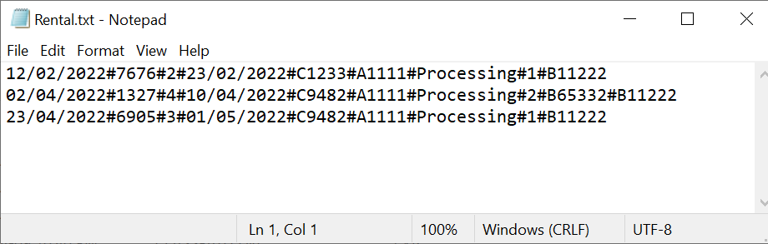

**Login account**

**If wrong input entered**

If symbol entered will throw exception and prompt error message

If alphabet entered will throw exception and prompt error message

If option other from menu entered will throw exception and prompt error message

**If login option 1 entered**

**Login Staff Account**

**If staff ID and password entered invalid**

User will need to choose login option then enter again the user ID and password

If user ID entered is invalid, wrong format or not in the file, error message will be prompt

**If staff ID and password entered valid**

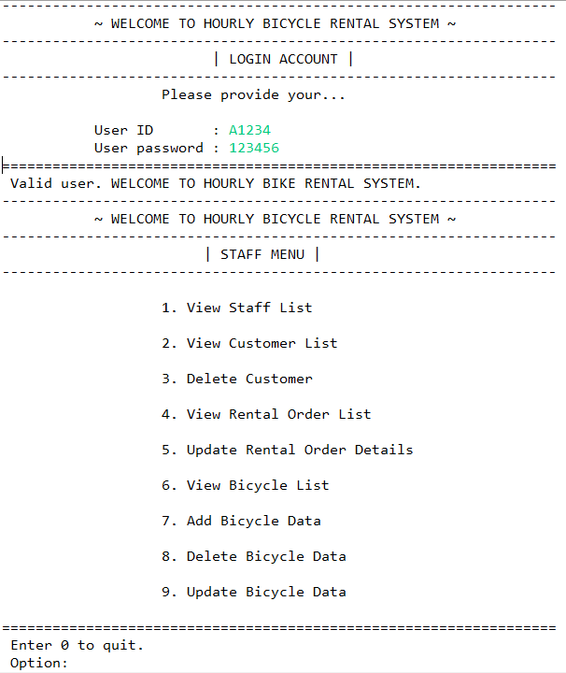

If valid user ID and password provided

Staff menu will display

**If staff menu option entered invalid**

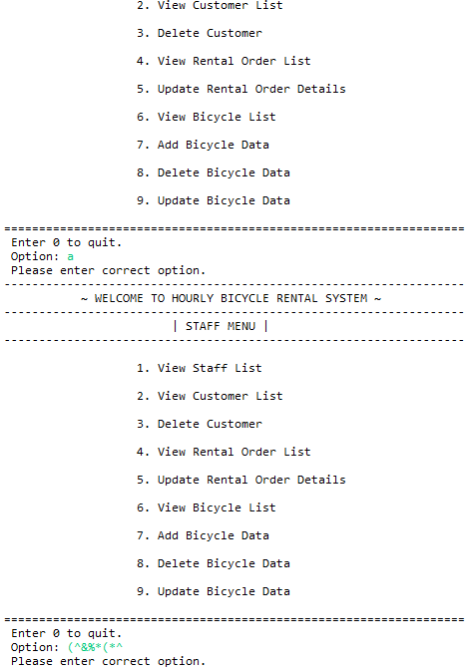

If invalid option such as alphabet and symbol entered, the system will loop until user entered a correct option

**If staff menu option 1 entered**

**View Staff List**

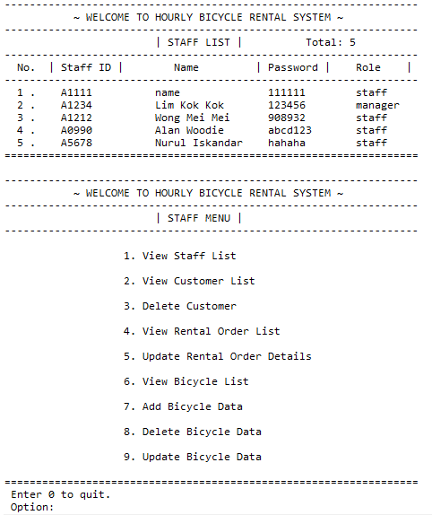

Staff list contain staff ID, name, password and role will be display

and back to staff menu automatically

**If staff menu option 2 entered**

**View Customer List**

**If customer ID entered is invalid**

If customer ID entered not in file, system will ask whether want to keep search ID or not

If invalid option such as alphabet and symbol entered, system will ask user whether want to search or not and re-enter again

**If customer ID is valid**

Customer details will be display

**If search option 0 is entered, will exit view customer list function, and exit to staff menu**

**If staff menu option 3 entered**

**Delete Customer**

**If customer ID wish to delete is invalid**

If wrong format and symbol entered, system will loop and allow user re-enter again

**If customer ID wish to delete is valid**

**Correct customer ID: C1234**

**If delete option 1 entered (delete customer)**

If wish to delete customer, message will be prompt showing delete successfully

**Check by view customer list**

Customer with customer ID ‘C1234’ has been delete

**If the customer had placed rental, then the customer cannot be deleted.**

Check: Customer with customer ID ‘C1233’ still available

**If staff menu option 4 entered**

**View Rental Order List**

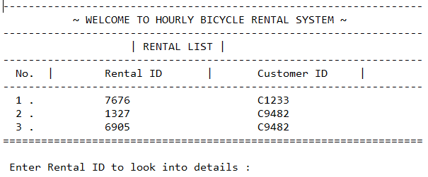

**If rental ID entered is invalid**

If wrong format, alphabet and symbol entered, system will prompt error message and allow user re-enter again

**If rental ID valid**

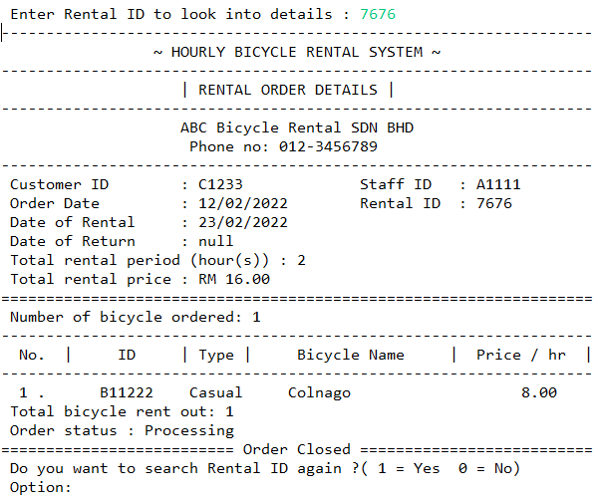

Order details with rental ID of ‘7676’ will be display

**If search option 1 entered will allow user keep to search other rental order.**

Same validation which is alphabet and symbol being done

**Search option 0 will quit the View Rental Order List function and back to staff menu.**

**If staff menu option 5 entered**

**Update Rental Order Details**

**Rental order list will be displayed to allow staff to view the rental order details that wish to update**

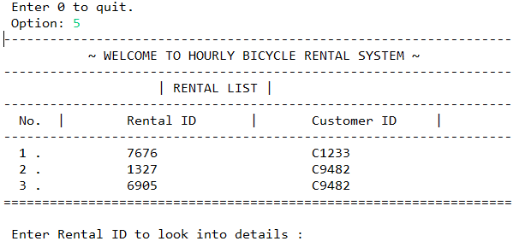

**Same validation done when invalid rental ID entered**

If rental ID entered in invalid number, symbol and alphabet, prompt error message and allow user re-enter again

**The system will display the rental details and proceed to update rental order if staff does not continue to search rental.**

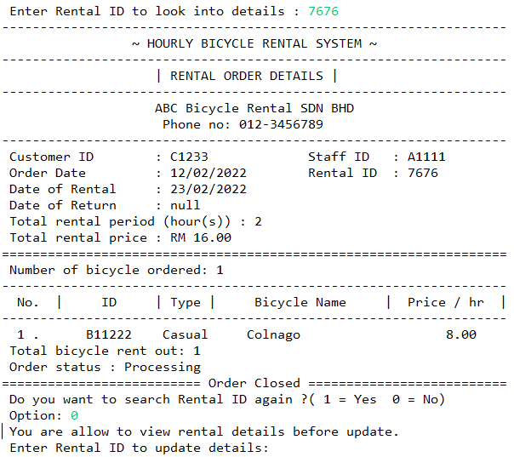

Once staff wish not to search rental, proceed to update rental order with rental ID provided

**Once the rental ID entered is invalid**

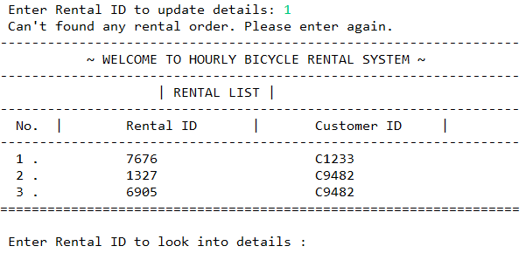

System will prompt error message and loop back to rental order list

**If correct rental ID that need to update is provided**

Staff are allow to update on rental status or staff ID assigned to order only

**If the update option entered is invalid**

If alphabet, symbol, or invalid option entered, the system will allow user re-enter again

**If the update option 1 entered: Update Rental Status**

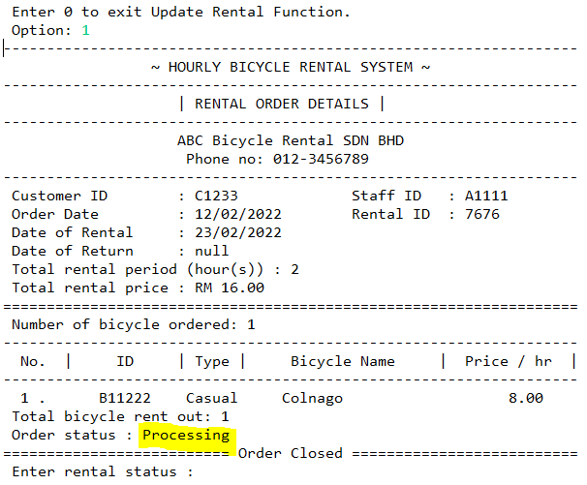

If staff choose to update rental, the highlighted part which is order status can be update

**If rental status entered is invalid**

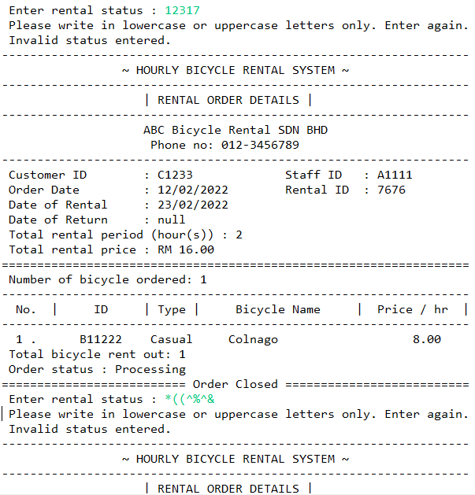

If the order status entered is number or symbol, system will allow user to re-enter again

**If rental status entered is valid**

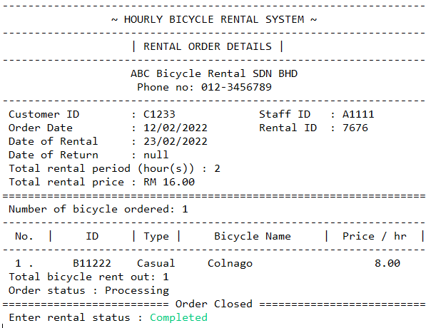

Update rental order with rental ID: 7676 rental status to ‘Completed’

**The system will display updated version after update or can check by View Rental List**

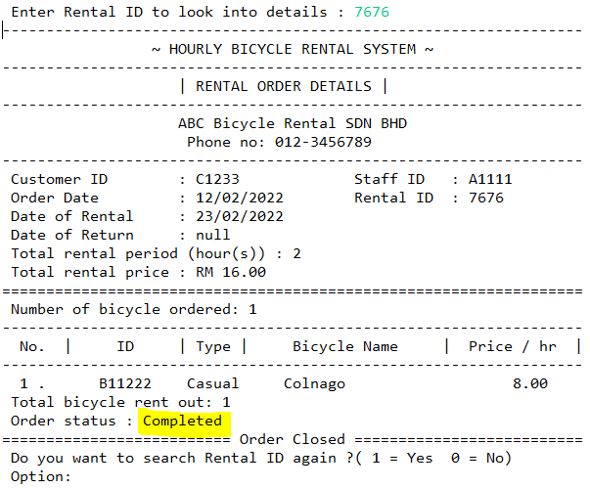

Rental order with rental ID: 7676 rental status has been updated to ‘Completed’

**If update option 2 entered : Update Staff ID**

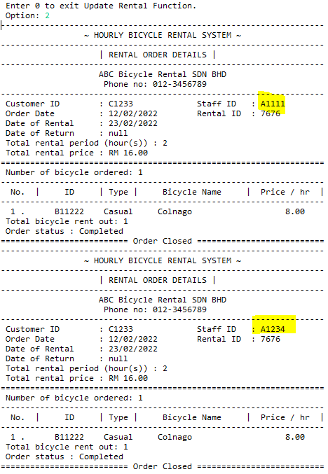

Update rental order with rental ID: 7676 staff ID to the staff that we login previously which is ‘A1234’

**If staff menu option 6 entered**

**View Bicycle List**

**If bicycle ID entered is invalid**

If bicycle ID entered in invalid number, alphabet or symbol, system will ask user whether want to search bicycle or not

**If bicycle ID entered is valid**

If bicycle ID entered is valid in record, system will display the bicycle details and ask whether user want to keep searching or not

**Same validation done for option entered**

Only option provide can be entered, other will prompt error message and allow user re-enter again

**If staff menu option 7 entered**

**Add Bicycle Data**

If bicycle ID entered in invalid format, system will ask user to re-enter util correct bicycle ID entered

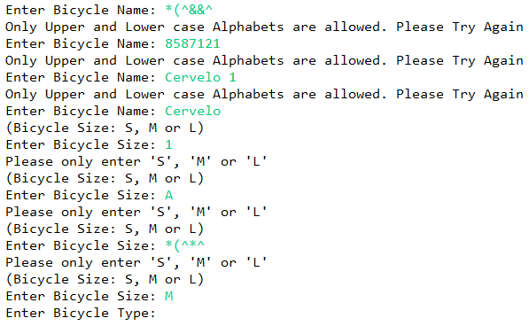

If bicycle size entered other than option provided, system will prompt the error message and ask user to re-enter again

If bicycle name entered in number or symbol, system will prompt the error message and ask user to re-enter again

If bicycle price entered symbol or alphabet, system will ask user to re-enter again

If bicycle type entered in number or symbol, system will ask user to re-enter again

If bicycle description entered symbol or number, system will ask user to re-enter again

**Check by View Bicycle List**

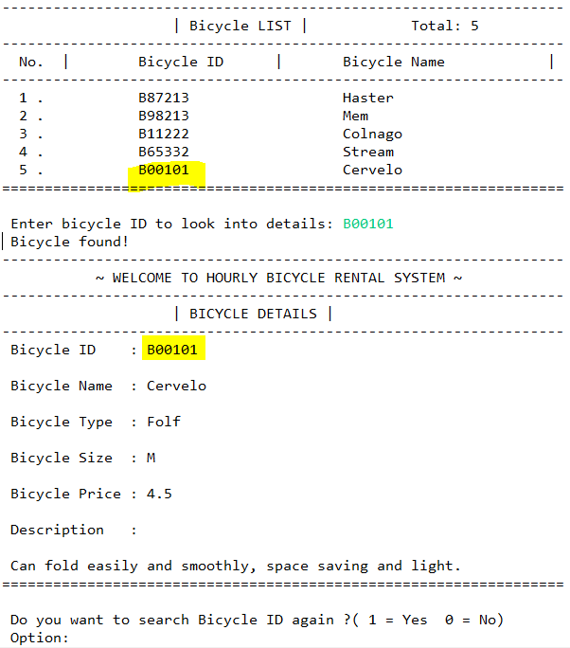

Check : bicycle with bicycle ID of ‘B00101’ is added

**If staff menu option 8 entered**

**Delete Bicycle Data**

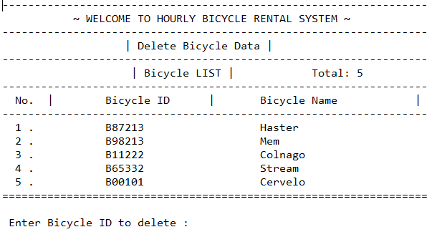

**If bicycle ID need to delete provided is invalid**

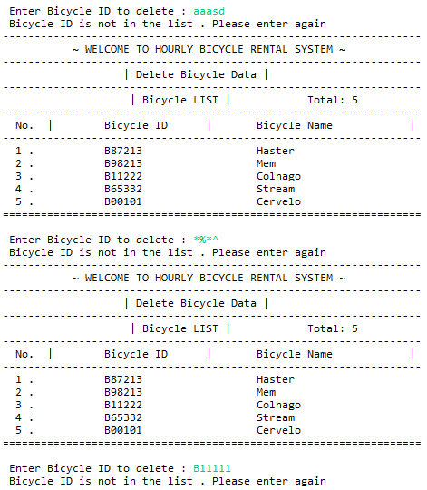

If bicycle ID wish to delete is in wrong format, system will allow user to re-enter again

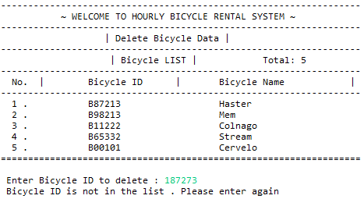

If bicycle ID wish to delete is in wrong format, system will allow user to re-enter again

**If bicycle ID entered is valid**

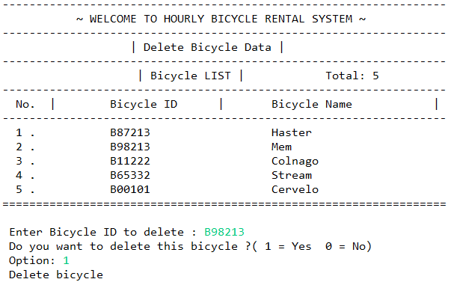

If bicycle ID is valid, it will ask confirmation from user whether wish to delete or not.

**▲The bicycle will be deleted if the bicycle does not include in any rental order**

**If the bicycle includes in rental order, then the bicycle cannot be deleted**

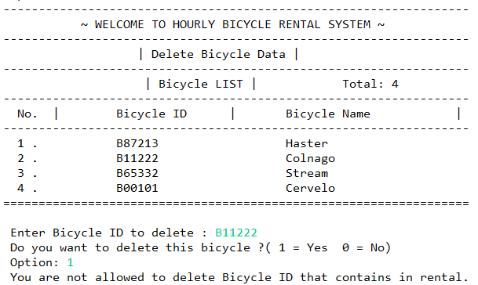

**If staff menu option 9 entered**

**Update Bicycle Data**

**If bicycle ID wish to update is invalid**

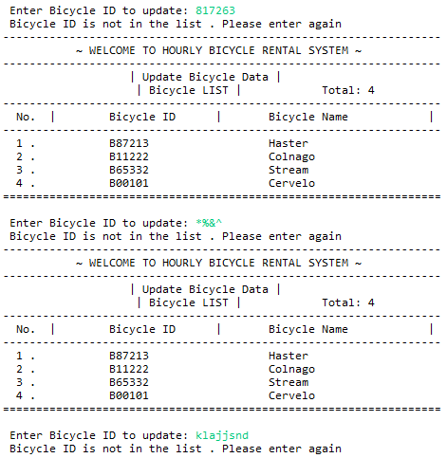

If bicycle ID wish to update is in wrong format, system will allow user to re-enter again

**If bicycle ID wish to update is valid**

If bicycle ID is valid and record in file, the bicycle details will be display and update options can be choose

**If update option 1 entered: Update Bicycle Name**

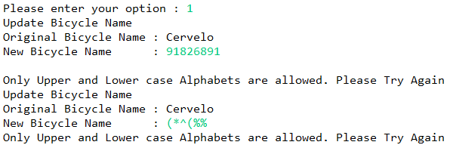

If bicycle name invalid which is number and symbol, system will allow user to re-enter again

**Update the bicycle name (Cervelo 🡪 Cervera)**



Update name from ‘Cervelo’ to ‘Cervera’

**If update option 2 entered: Update Bicycle Type**

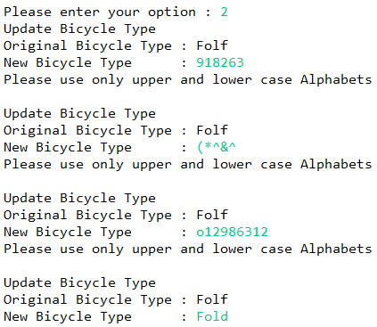

If bicycle type wish to update is in number or symbol, system will allow user to re-enter again

Update from folf to fold

**If update option 3 entered: Update Bicycle Description**

If bicycle description wish to update is in number, symbol, system will allow user to re-enter again

Update the word ‘light’ to ‘easy to handle’

**If update option 4 entered: Update Bicycle Size**

Valid option ‘S’ entered, update from ‘M’ to ‘S’

If bicycle size wish to update is in number, symbol or alphabet not in option, system will allow user to re-enter again

**If update option 5 entered: Update Bicycle Price per hour**

If bicycle price per hour wish to update is symbol or alphabet, system will allow user to re-enter again

Update price per hour from 4.5 to 4.0

If bicycle price per hour entered is not relevant which is greater than 15, prompt error message and re-enter again

**If update option 6 entered: Exit update**

**Check the updates by View Bicycle List**

Check: bicycle with bicycle ID B00101 have update details

* Name (Cervelo 🡪 Cervera)
* Type (Folf 🡪 Fold)
* Size (M 🡪 S)
* Price per hour(4.5 🡪 4.0)
* Description (light 🡪 easy handle)

**If 0 is entered, exit the staff account and back to login account interface**

**If option 2 entered**

**Login Customer Account**

**If no customer found, user can create a new customer account**

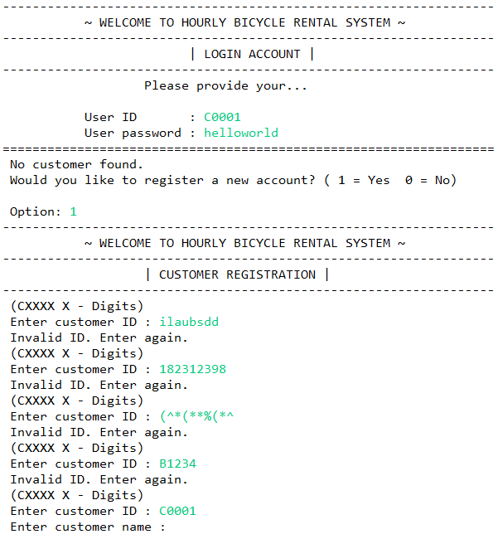

Customer ID and password not match in record

System will allow user to register new customer account

If customer ID is in wrong format, system will allow user to re-enter again

If gender entered other than ‘M’, ‘F’ or ‘O’, system will allow user to re-enter again

If customer password is in wrong format, system will allow user to re-enter again

If customer name is in number or symbol, system will allow user to re-enter again

If date entered in wrong format, symbol, alphabet or irrelevant date, system will allow user to re-enter again

If telephone number is in wrong format, symbol or alphabet, system will allow user to re-enter again

If email is in wrong format or symbol, system will allow user to re-enter again



**Check with View Customer List**

Check: new customer with ID of C0001 is added to record

**If customer ID and password is valid, login to customer menu**

Login to customer menu

Valid customer ID and password entered

**If customer menu option entered is invalid**

If customer menu option entered in invalid number, alphabet or symbol, system will ask user re-enter again

**If customer menu option 1 entered**

**View Personal Details**

Customer personal details will be display and automatically back to menu

**If option 2 entered**

**Update Customer Personal Details**

Customer personal details and update option will be display

**If update option entered is invalid**

If update option entered in invalid number, alphabet or symbol, system will ask user to re-enter again

**If update option 1 entered : Customer Name**

If customer name entered in number or symbol, system will ask user re-enter again

Update customer name from ‘Jesslyn Choo’ to ‘Jesslyn Chong’

**If update option 2 entered : Customer Gender**

If customer gender entered in number, alphabet not in option or symbol, system will ask user re-enter again

Update gender from ‘F’ to ‘O’

**If update option 3 entered : Customer Birthday Date**

Update birthday date from 16/02/1999 to 16/04/1999

If customer birthday date entered in number, alphabet, symbol or invalid date, system will ask user re-enter again

**If update option 4 entered : Customer Tel.No**

Update telephone number by adding a ‘6’ behind original number

If customer telephone number entered in number with wrong length, alphabet or symbol, system will ask user re-enter again

**If update option 5 entered : Email address**

If customer email address entered in number with wrong length, alphabet or symbol, system will ask user re-enter again

Update email from ‘jesschool16’ to ‘jesschong0416’

**If update option 6 entered : Exit update**

**If customer menu option 2 is entered**

**View Bicycle List**

**Same function and validation with staff**

**If bicycle ID entered is invalid**

If bicycle ID entered in invalid number, alphabet or symbol, system will ask user whether want to search bicycle or not

**If bicycle ID entered is valid**

If bicycle ID entered is valid in record, system will display the bicycle details and ask whether user want to keep searching or not

**Same validation done for option entered**

If option entered is out from option, symbol or alphabet, system will allow user to re-enter again

**If customer menu option 4 choose**

**Place Rental Order**

If rental date entered in number, alphabet, symbol or invalid date, system will ask user re-enter again

If rental hour entered in alphabet or symbol, system will ask user re-enter again

If order date entered in number, alphabet, symbol or invalid date, system will ask user re-enter again

**▲The order above is**

**Order date: 18/04/2022**

**Rental hour: 1**

**Rental date: 22/04/2022**

**Then, user able to provide bicycle ID they decided to rent**

Display message once bicycle successfully added and allow user to add more but maximum 5 bicycle

Validation for bicycle ID is done

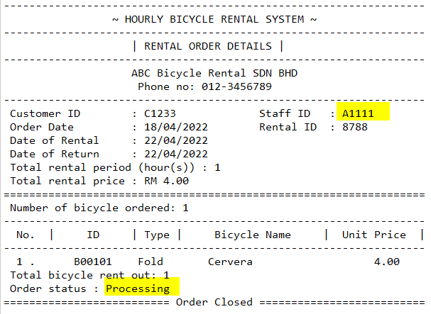

The rental order details will be generate and display.

Default staff ID: A1111 and order status: ‘Processing’ is assigned

**A rental receipt with rental ID: 8788 is generated**

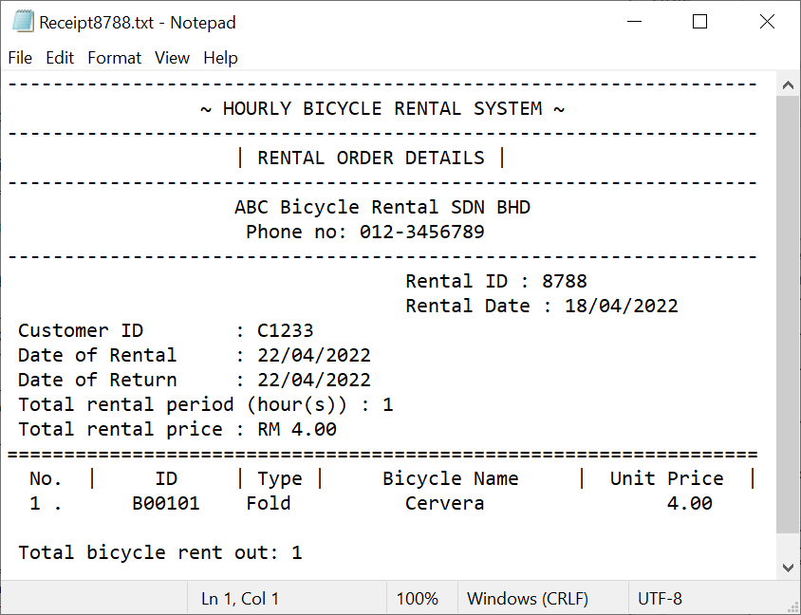

**If customer menu option 5 entered**

**Check Rental History**

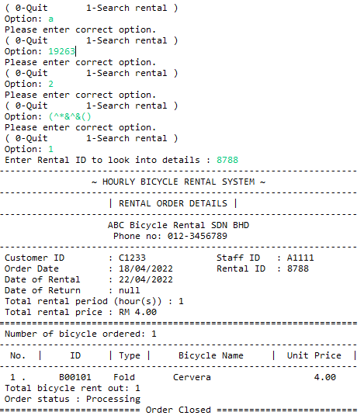

Rental order details will be display once the valid rental ID entered

If search rental option entered in number out from option, alphabet or symbol, system will ask user re-enter again

**If option 3 entered**

**Exit System**

**Check**

**File after program run**

**1. Rental file**

Rental order with ID 8788 is placed

**2. Customer file**

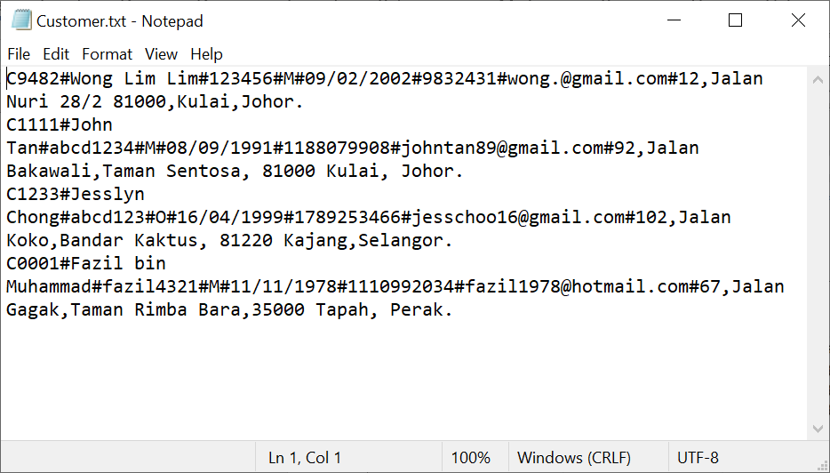

Customer details is updated

New customer is added

**3. Bicycle file**

**Since our bicycle bile is in .ser format, hence, bicycle details will be check using the system**

